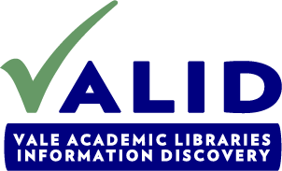
VALID Value Proposition
Revised 2-27-13

VALID Vision: To be VALE’s catalyst in transforming the role of New Jersey libraries in higher education through the use of a shared information technology infrastructure
VALID Strategies: Reduce duplicative efforts, eliminate information/service silos, and engage in enterprise-level collaboration
VALID Deliverables: By leveraging the shared information technology infrastructure VALID will deliver the following:
- Reduced cost of library operations in:
  - Resource sharing (ILL)
  - Cataloging
  - Acquisitions
  - Reference
  - Systems (software, hardware, maintenance)
- Easy access to state-wide collections

- State-wide academic library borrower card

- A more comprehensive research collection through reduced duplication
- Freed-up resources (staff, space and financial) for more strategic/transformative services
  - Student learning enhancement
  - Support for online education
  - Space for transformative uses through a last copy retention plan and weeding
  - Faculty research support (for example, data preservation, open access journals, digital humanities, etc.)
  - State-wide institutional repository
  - Industry-university partnerships

